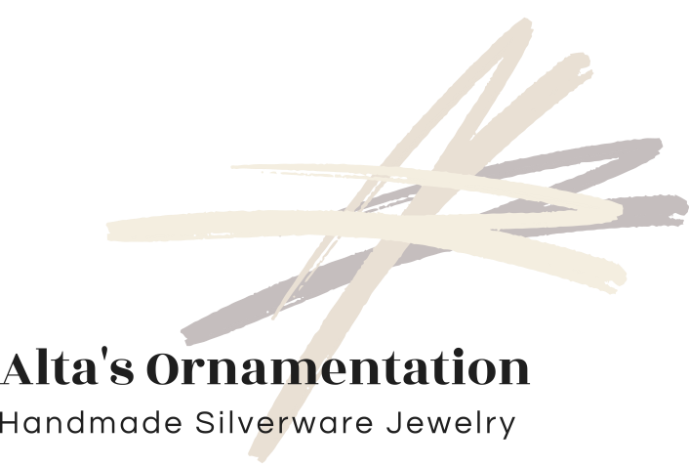 | Order Form

Contact Name:_____________________________
Company:_________________________________
Please fill out your order form and email it to altasornamentation@twcny.rr.com
Net 30, check, credit card or PayPal.
Style: Bordeaux | Size | Quantity
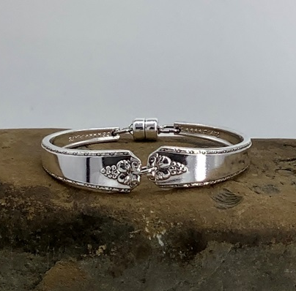 | XXSM-6.25”
 | XSM-6.75”
 | S-7”
 | M-7.5”
 | L-7.75”
 | XL-8”
 | XXL-8.5”
Style: Grenoble | Size | Quantity
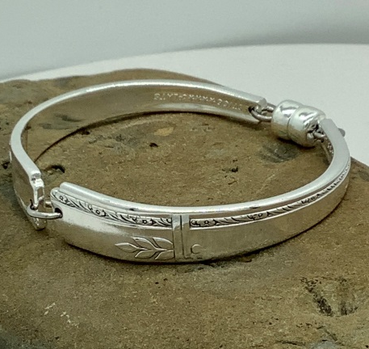 | XXSM-6.25”
 | XSM-6.75”
 | S-7”
 | M-7.5”
 | L-7.75”
 | XL-8”
 | XXL-8.5”

Style: Grosvenor | Size | Quantity
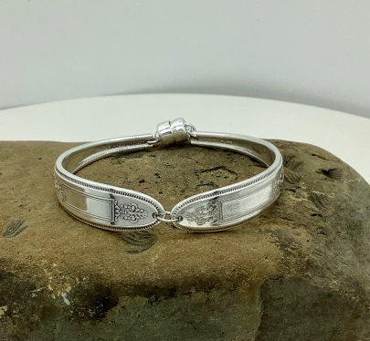 | XXSM-6.25”
 | XSM-6.75”
 | S-7”
 | M-7.5”
 | L-7.75”
 | XL-8”
 | XXL-8.5”
Style: | Queen Bess II |  | Quantity
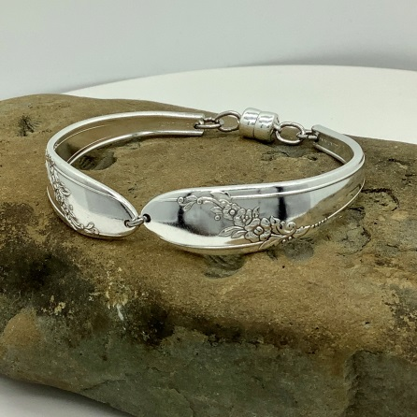 | XXSM-6.25”
 | XSM-6.75”
 | S-7”
 | M-7.5”
 | L-7.75”
 | XL-8”
 | XXL-8.5”
Style: | Silver Flower |  | Quantity
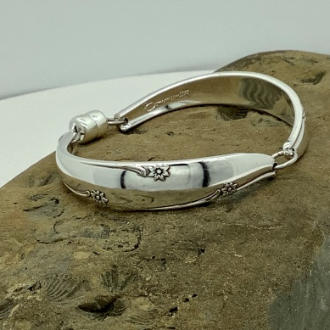 | XXSM-6.25”
 | XSM-6.75”
 | S-7”
 | M-7.5”
 | L-7.75”
 | XL-8”
 | XXL-8.5”

